**Lab Report**

**Of**

**Database Management System**

**Subject Code: CSC 265**



# Submitted To:-

NAGARJUNA COLLEGE OF IT

(AFFILATED TO TRIBHUVAN UNIVERSITY)

Shankhamul.Rd, Lalitpur

# Submitted By:-

# Shovit Regmi

University Registration Number: 5-2-429-32-2022

College Roll Number: 32

Program: Bachelor of Science in Computer Science and Information Technology (BSc.CSIT)

Semester: Fourth (4th)

**Lab 1**

1. Create a database named ‘yourname_csit’ and ‘csit079_yourname.

Description:

Syntax:

Query:

Output:

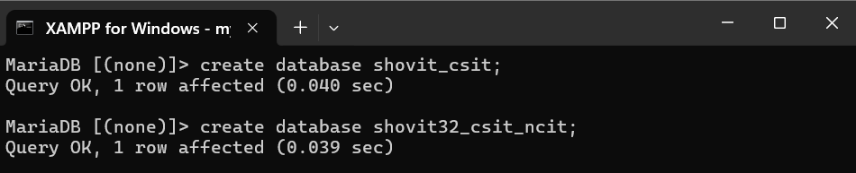

1. List all databases.

Description:

Syntax:

Query:

Output:

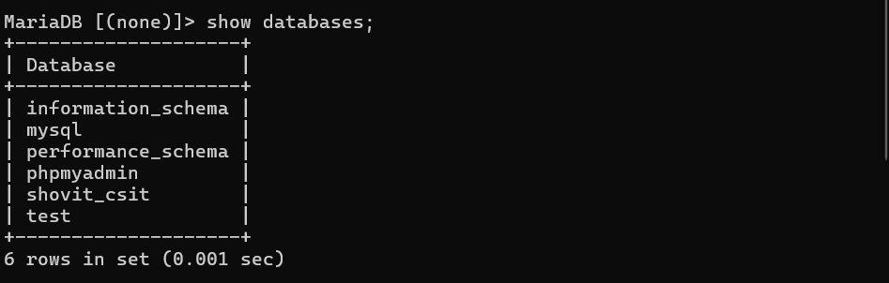

1. Delete database named ‘csit079_yourname’.

Description:

Syntax:

Query:

Output:

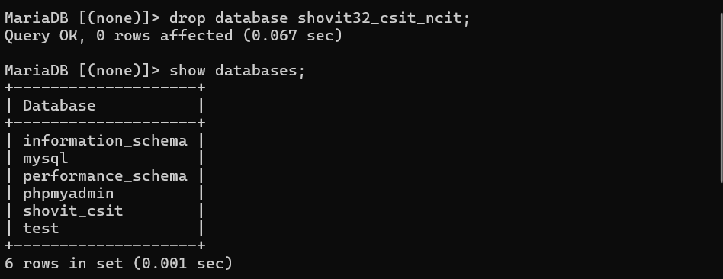

1. Select the database ‘yourname_csit.

Description:

Syntax:

Query:

Output:



1. Create table with primary key, foreign key constraints, not null constraints on names.

Description:

Syntax:

Query:

Output:

* 1. Department(dept_name, building, budget)

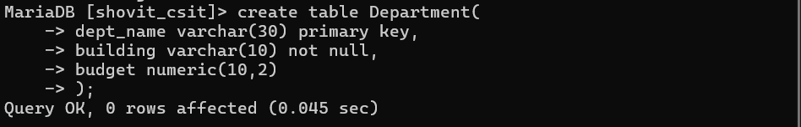

* 1. Instructors(id, name, address, dept_name)

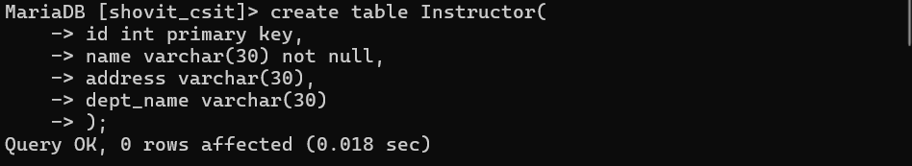

* 1. Student(id, name, tot_cred, dept_name)

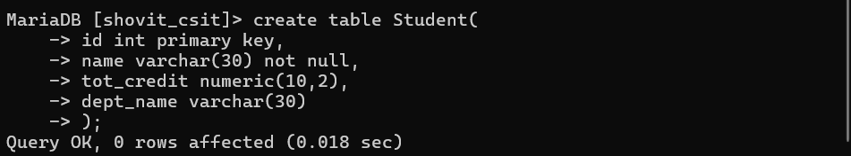

* 1. Staff(id, name, address, post)

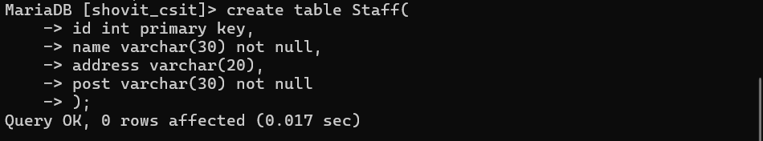

1. List all tables.

Description:

Syntax:

Output:

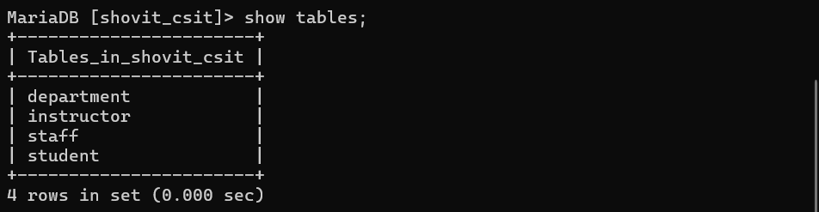

1. Describe table ‘Student’.

Description:

Syntax:

Query:

Output:

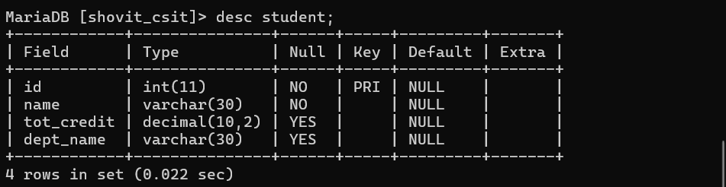

1. Change the table name Instructors to Instructor.

Description:

Syntax:

Query:

Output:

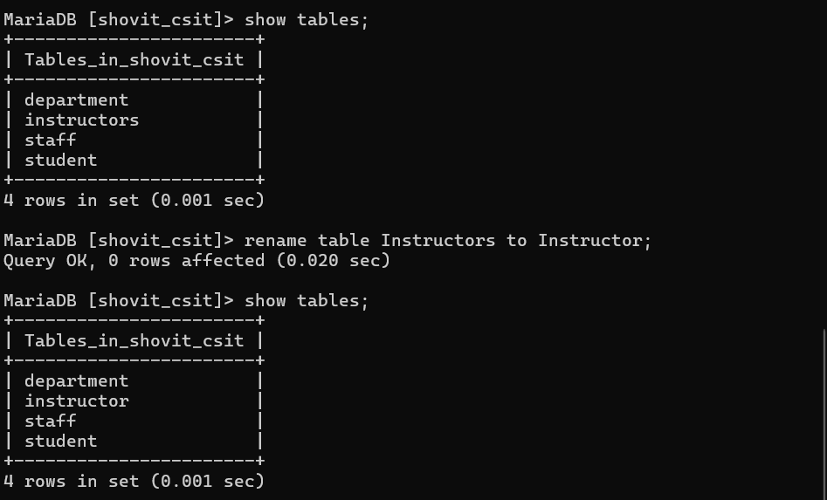

1. Alter table
   1. Remove address column from the Instructors table.

Description:

Syntax:

Query:

Output:

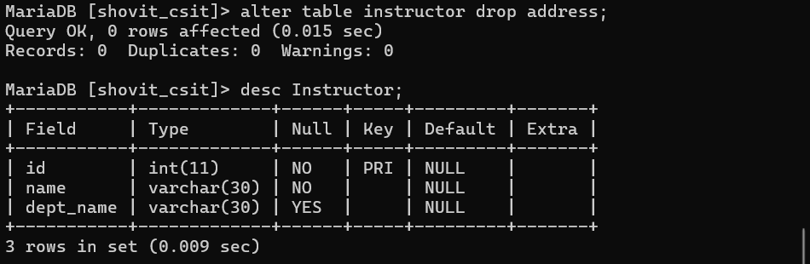

* 1. Change the column name tot_cred to total_credit.

Description:

Syntax:

Query:

Output:

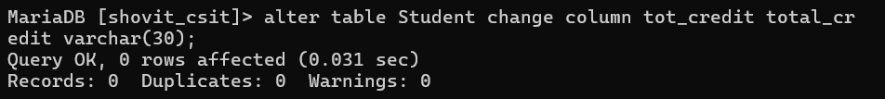

* 1. Drop and add primary key on table Student.

Description:

Syntax:

Query:

Output:

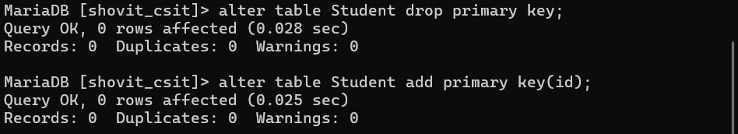

* 1. Drop and add foreign key on dept_name of Instructors.

Description:

Syntax:

Output:

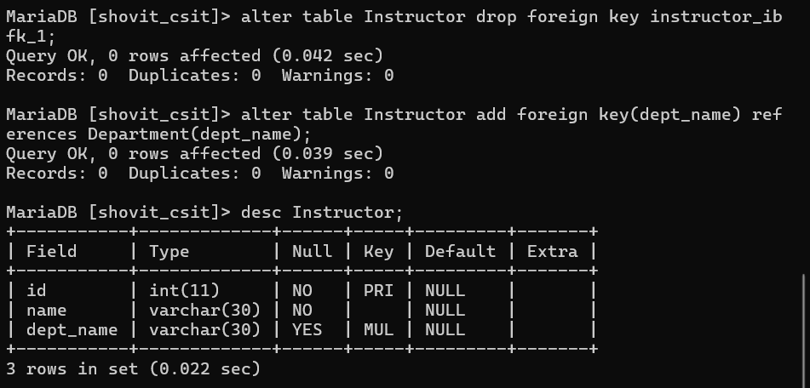

1. Delete table named ‘Staff’.

Description:

Syntax:

Query:

Output:



**Lab 2**

1. Insert records into a table

Description:

Syntax:

Output:

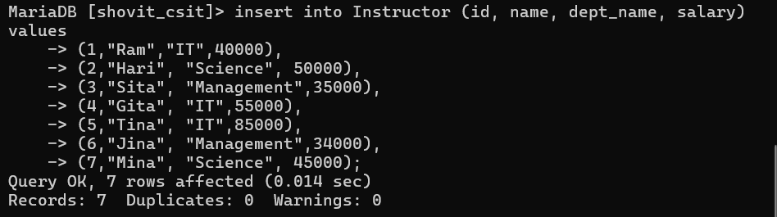

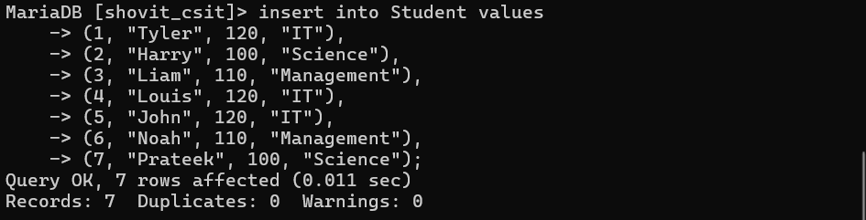

1. Select query

Description:

Syntax:

* 1. Retrieve department name and building from department table.

Query:

Output:

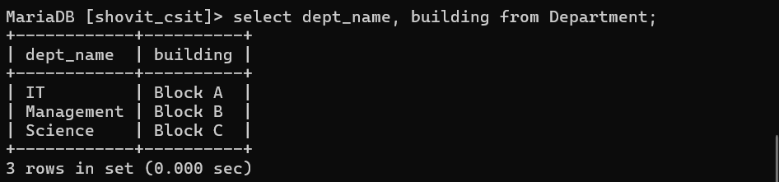

* 1. Retrieve all records of department.

Query:

Output:

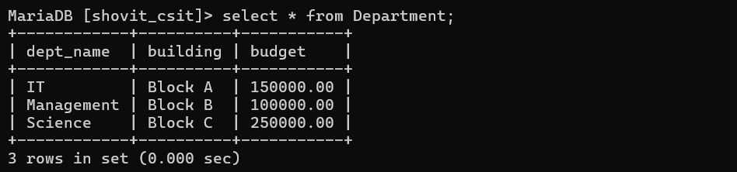

1. Where clause

Description:

Syntax:

* 1. Retrieve all records of department from Block A.

Query:

Output:

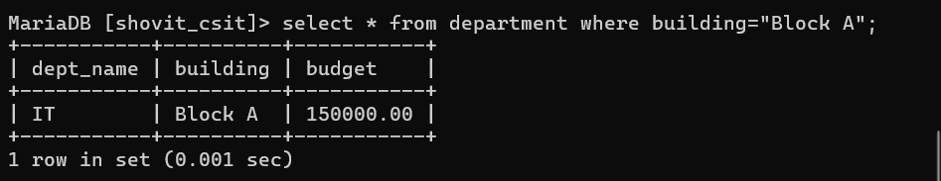

* 1. Retrieve name of all instructors whose salary is less than 50,000.

Query:

Output:

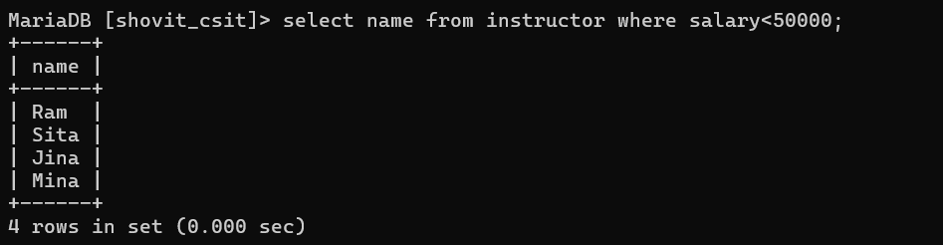

* 1. Retrieve name of all instructors in the IT department who have salary greater than 70,000.

Query:

Output:

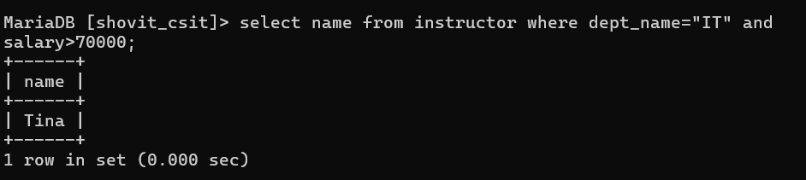

* 1. Find id, name and salary of instructors who are from Management department or whose salary is not 40,000.

Query:

Output:

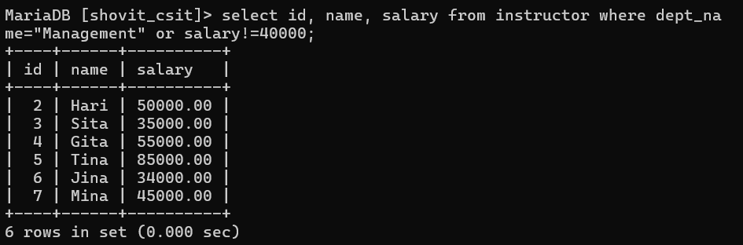

* 1. Find all records of instructors whose salary is between 30,000 and 70,000.

Query:

Output:

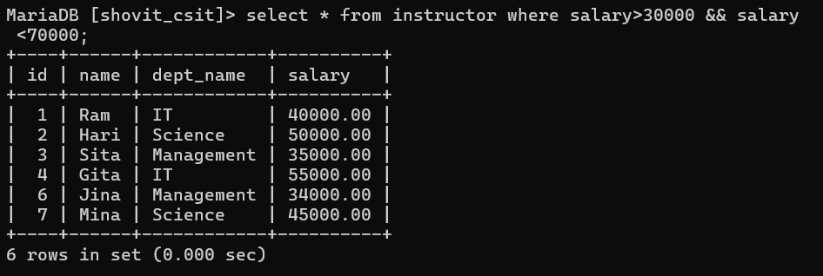

* 1. Find name of instructors whose salary is not between 30,000 and 70,000.

Query:

Output:



* 1. Find all records of instructors whose id is one of the following (1, 3, 5, 6, 7).

Query:

Output:

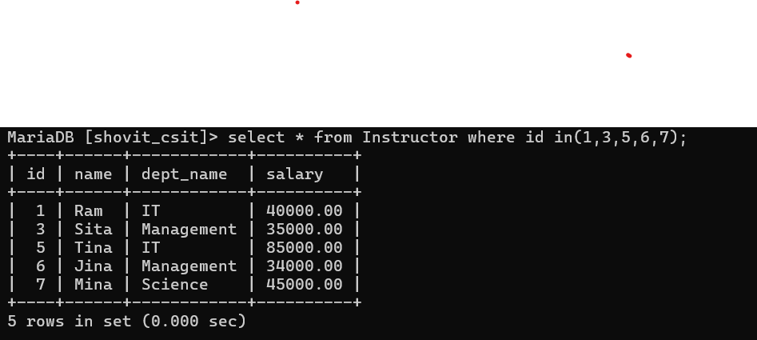

* 1. Find all records of instructors whose id is not in one of the following (1, 3, 5, 6, 7).

Query:

Output:

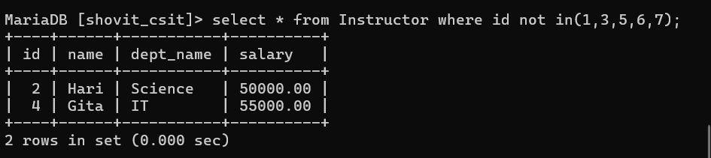

**Lab 3**

1. String Operations

Description:

Syntax:

* 1. Retrieve a concatenated string of department name, building, and budget for each department.

Query:

Output:

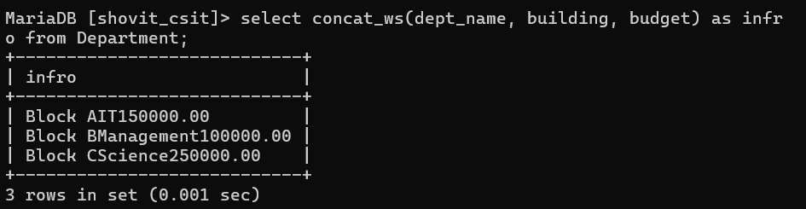

* 1. Retrieve a concatenated string of department name, building, and budget for each department using a comma as a separator.

Query:

Output:

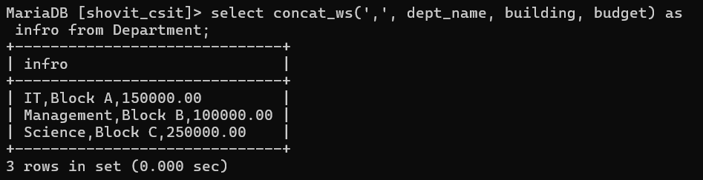

* 1. Extract the first five characters of name from the instructors table.

Query:

Output:

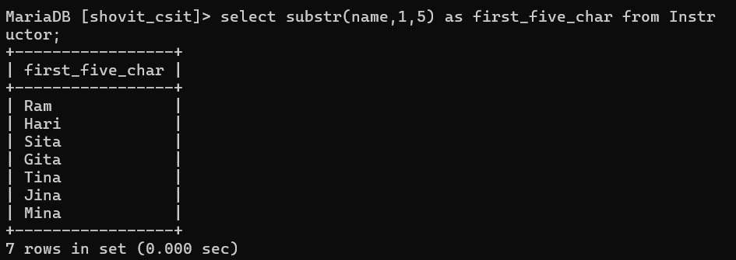

* 1. Retrieve the length of each instructor's name.

Query:

Output:

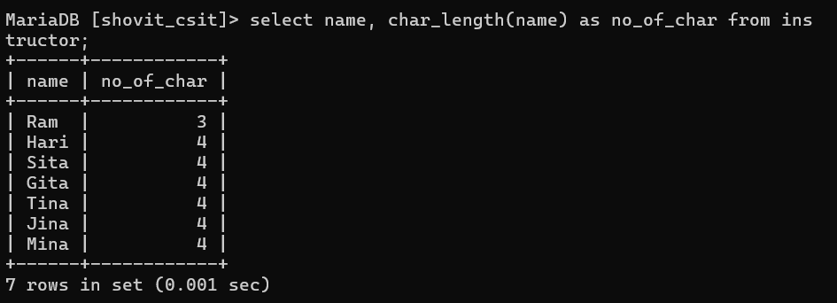

* 1. Retrieve all instructor names in uppercase.

Query:

Output:

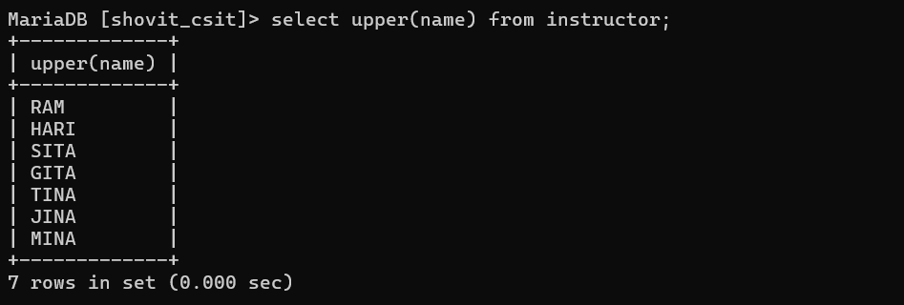

* 1. Retrieve all instructor names in lowercase.

Query:

Output:

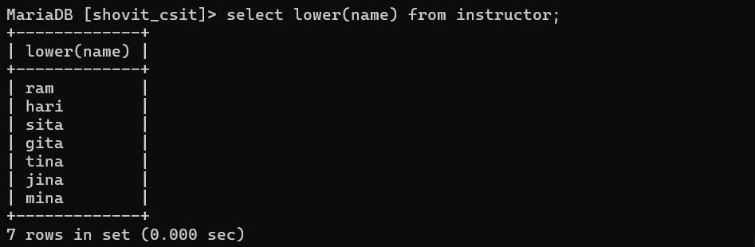

* 1. Remove leading and trailing spaces from instructor names.

Query:

Output:

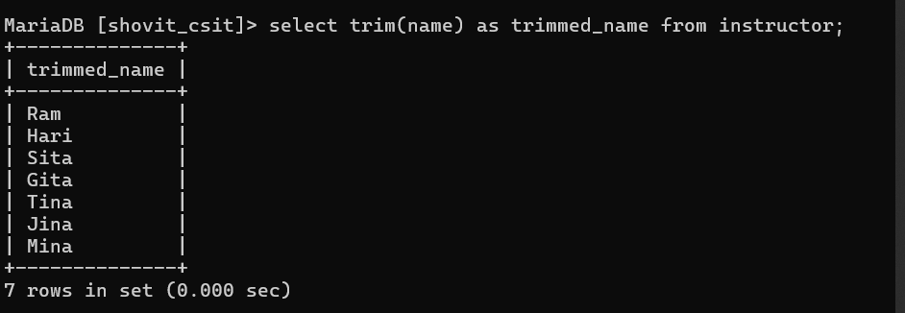

* 1. Replace 'a' with '@' in all instructor names.

Query:

Output:

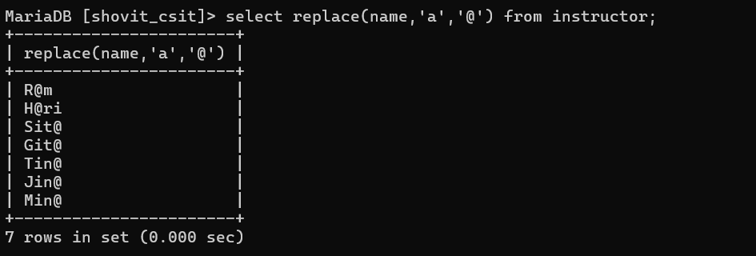

* 1. Find the position of 'a' in all instructor names.

Query:

Output:

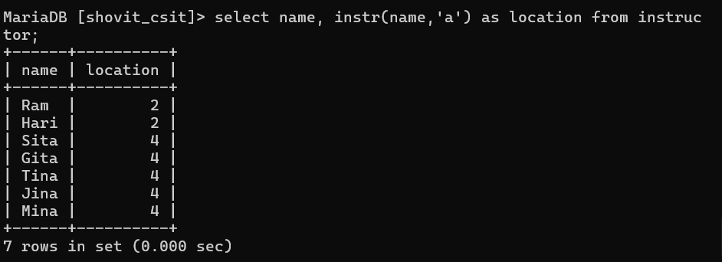

* 1. Reverse the characters in all instructor names.

Query:

Output:

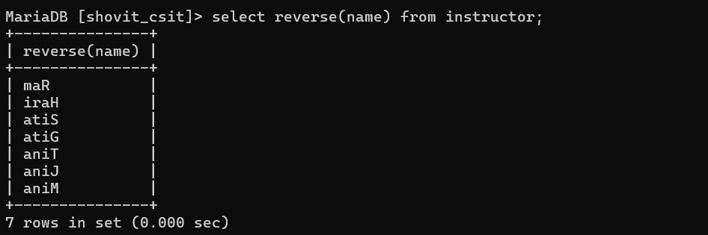

* 1. Compare the name of instructor with ID 1 to “Hari”.

Query:

Output:

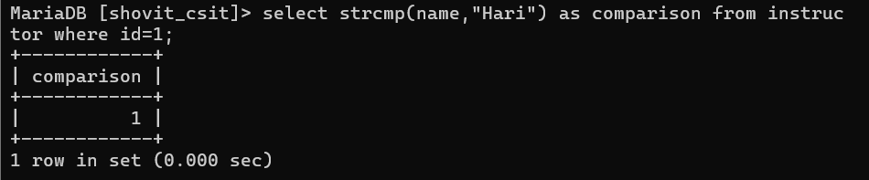

1. Like Clause

Description:

Syntax:

* 1. Retrieve name of instructors whose name starts with ‘as’.

Query:

Output:



* 1. Retrieve name of department that ends with‘t’.

Query:

Output:

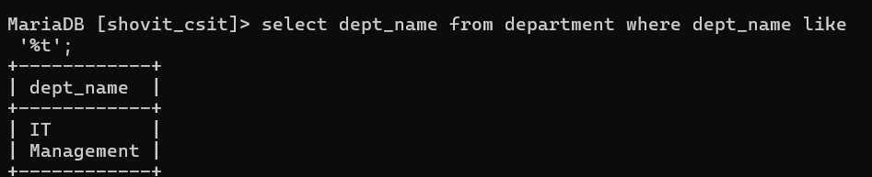

* 1. Retrieve name of instructor that starts with‘s’ and are at least 3 characters in length.

Query:

Output:

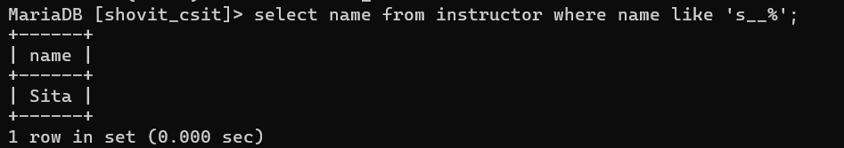

* 1. Retrieve id and name of instructor of four-digit length name that starts with ‘r’ and ends with ‘n’.

Query:

Output:



* 1. Retrieve department name and building whose building name includes the substring ‘oc’.

Query:

Output:



1. Ordering the display of tuples

Description:

Syntax:

* 1. Find name and salary of all instructors in the order of salary.

Query:

Output:

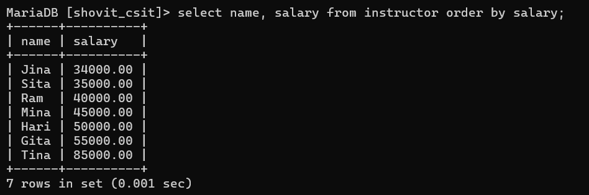

* 1. List the records of all instructors in descending order of their name.

Query:

Output:

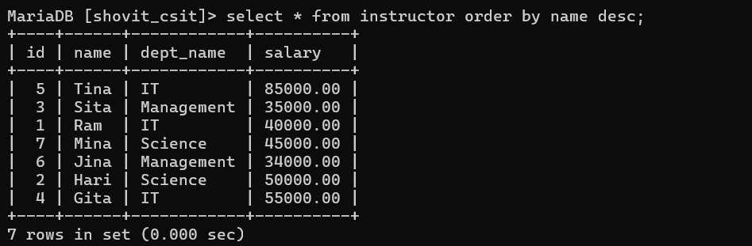

* 1. List all name of instructors in ascending order and salary in descending order

Query:

Output:

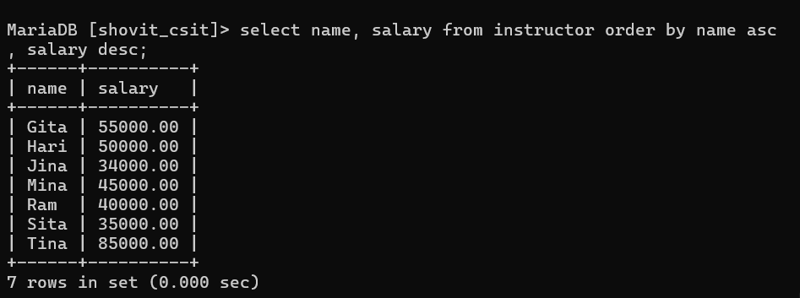

**Lab 4**

1. Aggregate Functions

Description:

Syntax:

* 1. Find the maximum and minimum salary of the instructors

Query:

Output:

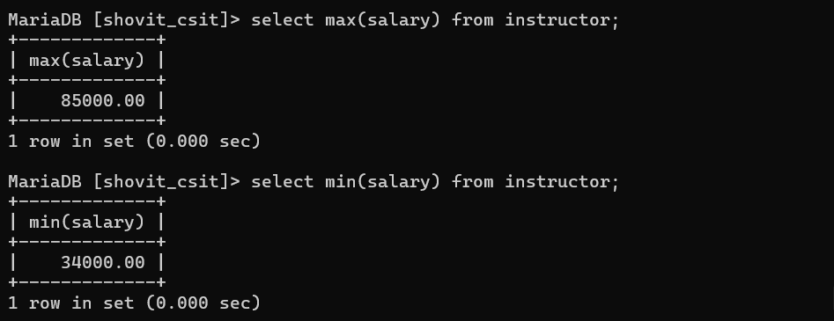

* 1. Find the average salary of the instructors.

Query:

Output:

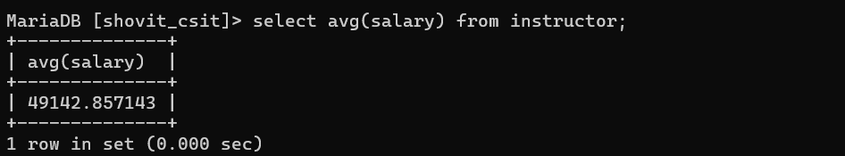

* 1. Find the total number of records in the department table.

Query:

Output:

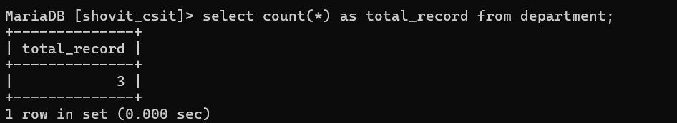

* 1. Find the number of instructors from Lalitpur.

Query:

Output:

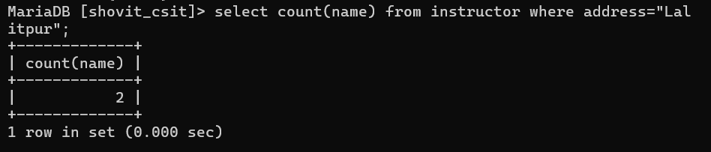

* 1. Find the total salary of instructor in the IT department.

Query:

Output:

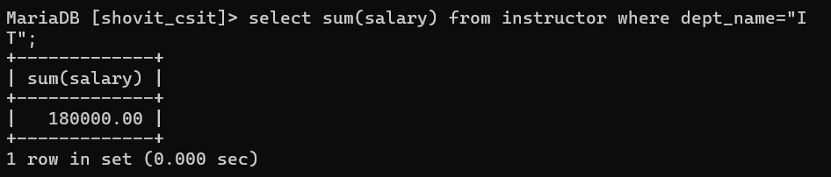

1. Aggregation with Grouping

Description:

Syntax:

* 1. Find the average salary in each department.

Query:

Output:

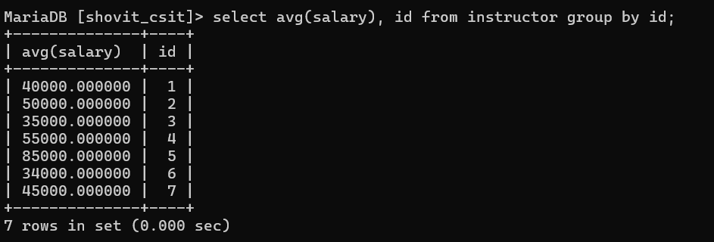

* 1. Find the number of instructors in each department sorted from high to low.

Query:

Output:

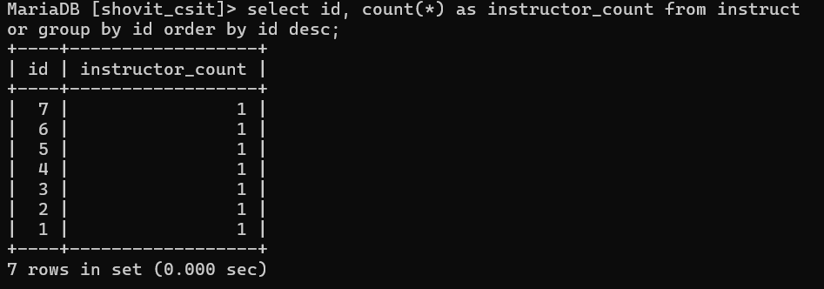

1. Having clause

Description:

Syntax:

* 1. Find those departments where the average salary of the instructors is more than 40,000.

Query:

Output:

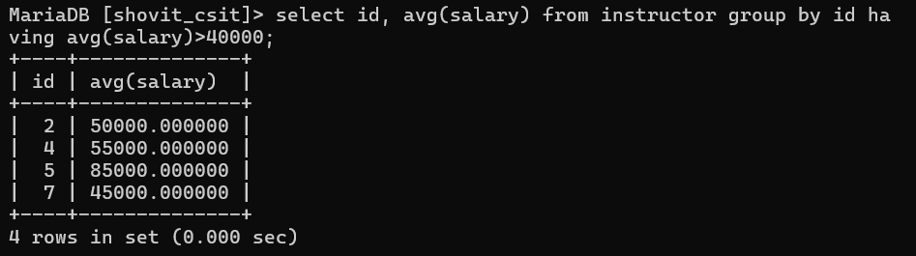

* 1. List the number of instructors in each department with more than 2 instructors.

Query:

Output



**Lab 5**

1. NULL Values

Description:

Syntax:

* 1. List all instructors with a NULL value in the salary field.

Query:

Output



* 1. List all instructors with a value in the address field.

Query:

Output

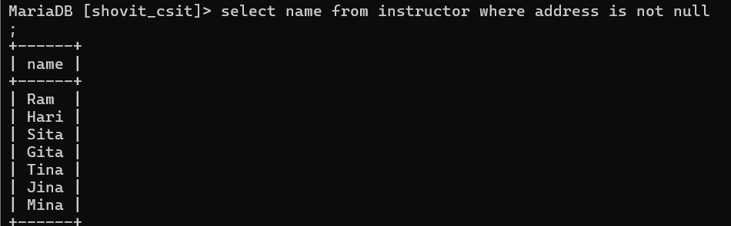

1. Set Membership

Description:

Syntax:

* 1. Find all instructor names who works in Block A building with budget greater than Rs. 1,00,000.

Query:

Output:

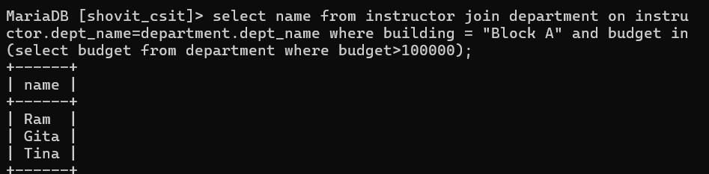

* 1. Find all instructor names who doesn’t works in Block A building with budget greater than Rs. 1,00,000.

Query:

Output:

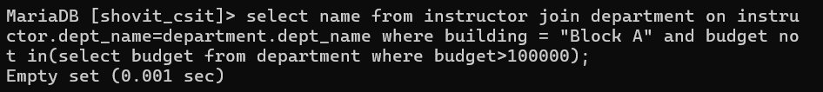

1. Set Comparison

Description:

Syntax:

* 1. Find the names of all instructors whose salary is greater at least one instructor from Lalitpur.

Query:

Output:

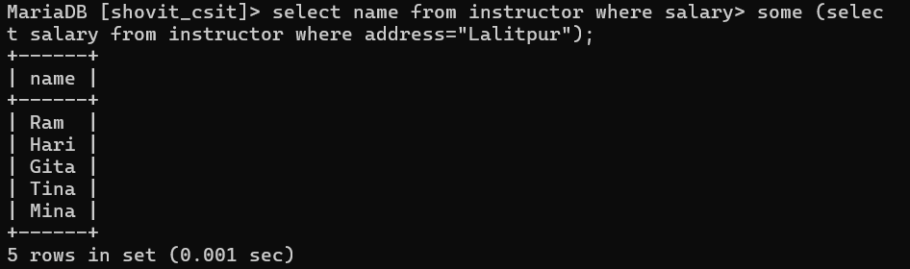

* 1. Find all names of instructors whose salary is less than at least one instructor from Lalitpur.

Query:

Output:

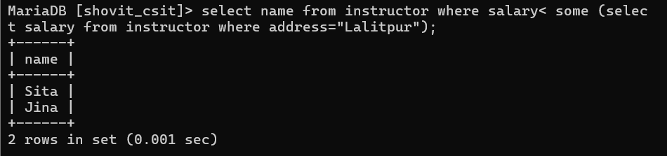

1. Exists and Not Exists Operator

Description:

Syntax:

* 1. Retrieve only the information of department which includes one or more instructors.

Query:

Output:

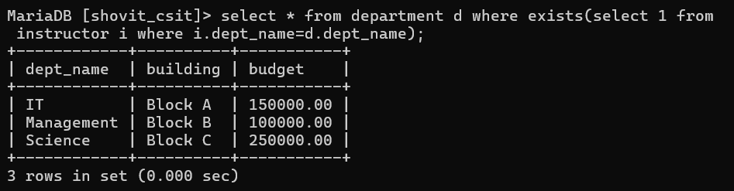

* 1. Retrieve only the information of department which does not have any instructors.

Query:

Output:



**Lab 6**

1. Views

Description:

Syntax:

* 1. Create a view higher_budget_department that displays the department name and budget of the department whose budget is greater than Rs. 200000.

Query:

Output:



* 1. Display the information of the view ‘higher_budget_department’.

Query:

Output:

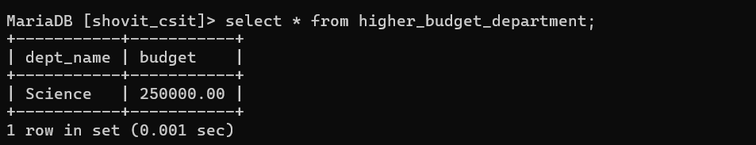

* 1. Drop the view ‘higher_budget_department’.

Query:

Output:



1. Updating tuples

Description:

Syntax:

* 1. Increase salary for only instructors with salary less than Rs.50,000 by 5%.

Query:

Output:

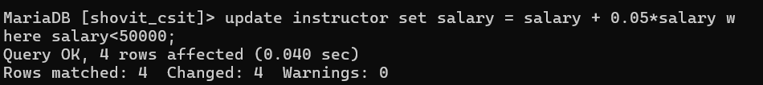

* 1. Change the building name of the department IT to Block D.

Query:

Output:

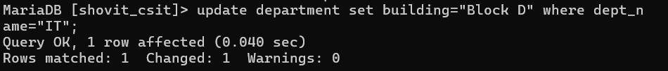

1. Deletion of tuples

Description:

Syntax:

* 1. Delete all instructors from the Science department.

Query:

Output:



* 1. Delete all instructors with a salary between Rs.40,000 and Rs.50,000.

Query:

Output:



1. Join

Description:

Syntax:

* 1. Display the information of department and their respective instructors using inner join.

Query:

Output:

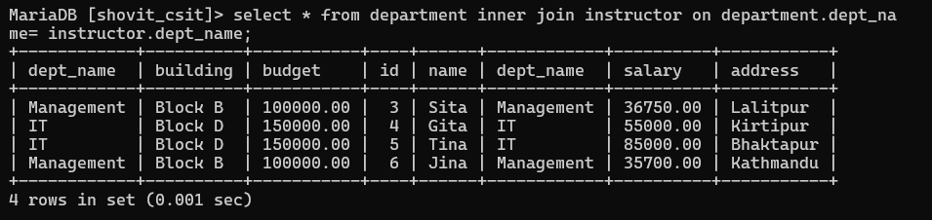

* 1. Display the information of department and their respective instructors using natural join.

Query:

Output:

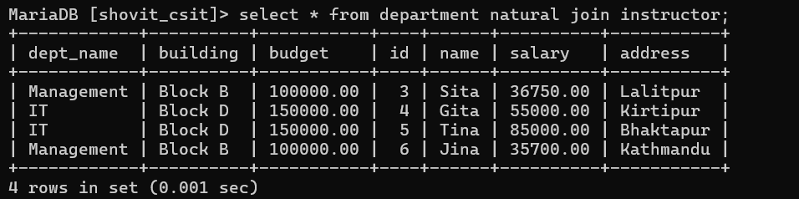

* 1. Display the information of department and instructors using left join.

Query:

Output:

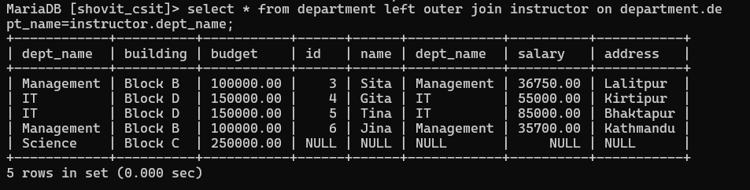

* 1. Display the information of department and instructors using right join.

Query:

Output:

